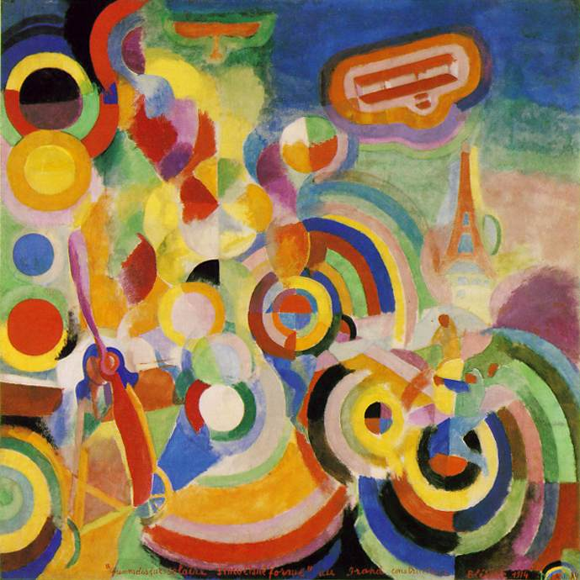
SAT | TRAJANJE SATA
ZVONI | 07:55
1. SAT | 08:00 – 08:45
2. SAT | 08:50 – 09:35
3. SAT | 09:50 – 10:35
4. SAT | 10:50 – 11:35
5. SAT | 11:40 – 12:25
6. SAT | 12:30 – 13:15
7. SAT | 13:20 – 14:05
8. SAT | 14:10 – 14:55
9. SAT | 15:00 – 15:45
10. SAT | 15:50 – 16:35
11. SAT | 16:40 – 17:25

